**Topics: Normal distribution, Functions of Random Variables**

1. The time required for servicing transmissions is normally distributed with *μ* = 45 minutes and *σ* = 8 minutes. The service manager plans to have work begin on the transmission of a customer’s car 10 minutes after the car is dropped off and the customer is told that the car will be ready within 1 hour from drop-off. What is the probability that the service manager cannot meet his commitment?
2. 0.3875
3. 0.2676
4. 0.5
5. 0.6987

Ans- : Let the probability of not meeting the commitment be P(E)

We have to calculate the z score of the scenario first.

Given: *μ* = 45 and *σ* = 8 , time 60-10=50

Z score at 50 🡪 (time-mean time)/std

= (50-45)/8 = 0.625

Corresponding probability from z table = 0.7324

P(E)=1-0.7324 = **0.2676(B)**

1. The current age (in years) of 400 clerical employees at an insurance claims processing center is normally distributed with mean *μ* = 38 and Standard deviation *σ* =6. For each statement below, please specify True/False. If false, briefly explain why.
2. More employees at the processing center are older than 44 than between 38 and 44.

**Ans-** The range between ages 38 and 44 is within one standard deviation from the mean. This means that it contains about 34% of 400,approx.=136 people .Going beyond age 44 will result in about 16% approx.=64 people which is less than the former. Therefore, the answer is **False**

1. A training program for employees under the age of 30 at the center would be expected to attract about 36 employees.

Ans- 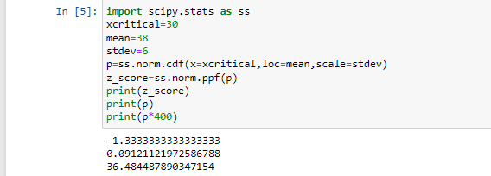

1. If *X1* ~ *N*(μ, σ2) and *X*2 ~ *N*(μ, σ2) are *iid* normal random variables, then what is the difference between 2 *X*1 and *X*1 + *X*2? Discuss both their distributions and parameters.

Ans- : As both are independent normal random variables, X1 + X2 is normal with

N(µ1+µ2,σ12+σ22). And 2X1 will just scale the normal distribution by 2 times

1. Let X ~ N(100, 202). Find two values, *a* and *b*, symmetric about the mean, such that the probability of the random variable taking a value between them is 0.99.
2. 90.5, 105.9
3. 80.2, 119.8
4. 22, 78
5. 48.5, 151.5
6. 90.1, 109.9

Ans- > qnorm(0.995,100,20)

**151.5166**

> qnorm(0.005,100,20)

**48.48341**

1. Consider a company that has two different divisions. The annual profits from the two divisions are independent and have distributions Profit1 ~ N(5, 32) and Profit2 ~ N(7, 42) respectively. Both the profits are in $ Million. Answer the following questions about the total profit of the company in Rupees. Assume that $1 = Rs. 45
2. Specify a Rupee range (centered on the mean) such that it contains 95% probability for the annual profit of the company

Ans- According sum of normal random variables rules,we can add up the profits.

Annual_profit ~N(5+7,32+42)

=N(12,52) Rupee Range =[99008103.48,980991896.52]

Rupee Range is approx. **99Million Rupees to 980Million Rupees.**

.

1. Specify the 5th percentile of profit (in Rupees) for the company

Ans-

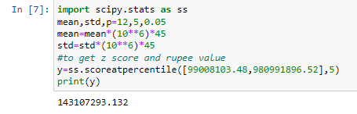

1. Which of the two divisions has a larger probability of making a loss in a given year?

Ans- 